Advanced C programming
Module 2
Assignment Questions:
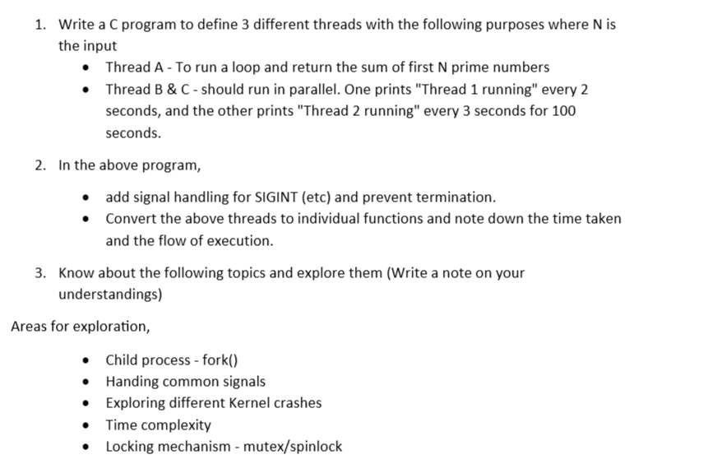
Answers:

1. Multithreading Program in C

Algorithm
- Read value of N.
- Create Thread A to calculate sum of first N prime numbers.
- Create Thread B to print "Thread 1 running" every 2 seconds.
- Create Thread C to print "Thread 2 running" every 3 seconds.
- Execute all threads in parallel.
- Wait for all threads to complete.
Program:
#include <stdio.h>
#include <pthread.h>
#include <unistd.h>
int N;
/* PRIME CHECK FUNCTION */
int isPrime(int num)
{
int i;
if(num < 2)
{
return 0;
}
for(i = 2; i * i <= num; i++)
{
if(num % i == 0)
{
return 0;
}
}

return 1;
}
/* THREAD A */
void* sumPrime(void* arg)
{
int count = 0;
int num = 2;
int sum = 0;
while(count < N)
{
if(isPrime(num))
{
sum += num;
count++;
}

num++;
}
printf("\nSum of first %d prime numbers = %d\n", N, sum);
pthread_exit(NULL);
}
/* THREAD B */
void* thread1(void* arg)
{
int i;
for(i = 0; i < 50; i++)
{
printf("Thread 1 running\n");
sleep(2);
}
pthread_exit(NULL);
}
/* THREAD C */
void* thread2(void* arg)
{
int i;
for(i = 0; i < 34; i++)
{
printf("Thread 2 running\n");
sleep(3);
}
pthread_exit(NULL);
}
int main()
{
pthread_t t1, t2, t3;
printf("Enter N: ");
scanf("%d", &N);
/* CREATE THREADS */
pthread_create(&t1, NULL, sumPrime, NULL);
pthread_create(&t2, NULL, thread1, NULL);
pthread_create(&t3, NULL, thread2, NULL);
/* WAIT FOR THREADS */
pthread_join(t1, NULL);
pthread_join(t2, NULL);
pthread_join(t3, NULL);
printf("\nAll threads completed.\n");
return 0;
}
O/P:
Enter N: 5

Sum of first 5 prime numbers = 28
Thread 1 running
Thread 2 running
Thread 1 running
Thread 2 running
Thread 1 running
Thread 1 running
Thread 2 running
Thread 1 running
Thread 2 running
Thread 1 running
Thread 1 running
Thread 2 running
Thread 1 running
Thread 2 running
Thread 1 running
Thread 1 running
Thread 2 running
Thread 1 running
Thread 2 running
Thread 1 running
Thread 1 running
Thread 2 running
Thread 1 running
Thread 2 running
Thread 1 running
Thread 1 running
Thread 2 running
Thread 1 running
Thread 2 running
Thread 1 running
Thread 1 running
Thread 2 running
Thread 1 running
Thread 2 running
Thread 1 running
Thread 2 running
Thread 1 running
Thread 1 running
Thread 2 running
Thread 1 running
Thread 2 running
Thread 1 running
Thread 1 running
Thread 2 running
Thread 1 running
Thread 2 running
Thread 1 running
Thread 1 running
Thread 2 running
Thread 1 running
Thread 2 running
Thread 1 running
Thread 1 running
Thread 2 running
Thread 1 running
Thread 2 running
Thread 1 running
Thread 1 running
Thread 2 running
Thread 1 running
Thread 2 running
Thread 1 running
Thread 1 running
Thread 2 running
Thread 1 running
Thread 2 running
Thread 1 running
Thread 1 running
Thread 2 running
Thread 1 running
Thread 2 running
Thread 1 running
Thread 1 running
Thread 2 running
Thread 1 running
Thread 2 running
Thread 1 running
Thread 1 running
Thread 2 running
Thread 1 running
Thread 2 running
Thread 1 running
Thread 1 running
Thread 2 running

All threads completed.

=== Code Execution Successful ===
Proof:
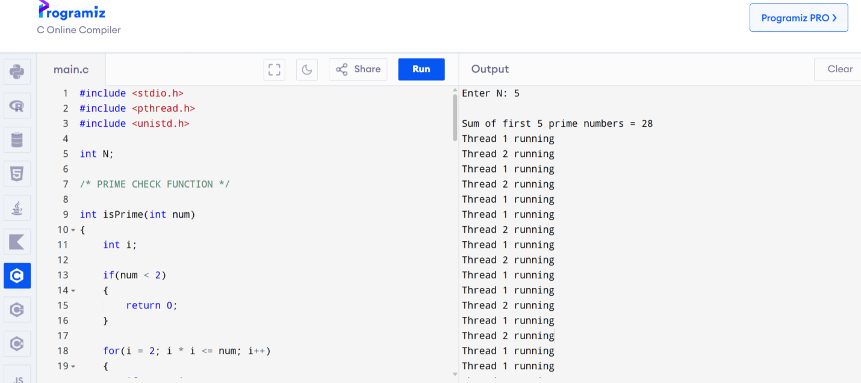

2. Signal Handling in Threads

Algorithm
- Create a signal handler function.
- Capture SIGINT signal using signal().
- Prevent program termination when Ctrl + C is pressed.
- Create separate thread functions.
- Execute threads in parallel.
- Display execution flow and completion message.

Program

#include <stdio.h>

#include <pthread.h>

#include <unistd.h>

#include <signal.h>

int N;

/* SIGNAL HANDLER */

void handleSignal(int sig)

{

printf("\nSIGINT received.\n");

printf("Program termination prevented.\n");

}

/* PRIME CHECK FUNCTION */

int isPrime(int num)

{

int i;

if(num < 2)

{

return 0;

}

for(i = 2; i * i <= num; i++)

{

if(num % i == 0)

{

return 0;

}

}

return 1;

}

/* THREAD A */

void* sumPrime(void* arg)

{

int count = 0;

int num = 2;

int sum = 0;

while(count < N)

{

if(isPrime(num))

{

sum += num;

count++;

}

num++;

}

printf("\nSum of first %d prime numbers = %d\n", N, sum);

pthread_exit(NULL);

}

/* THREAD B */

void* thread1(void* arg)

{

int i;

for(i = 0; i < 10; i++)

{

printf("Thread 1 running\n");

sleep(2);

}

pthread_exit(NULL);

}

/* THREAD C */

void* thread2(void* arg)

{

int i;

for(i = 0; i < 10; i++)

{

printf("Thread 2 running\n");

sleep(3);

}

pthread_exit(NULL);

}

int main()

{

pthread_t t1, t2, t3;

/* SIGNAL REGISTRATION */

signal(SIGINT, handleSignal);

printf("Enter N: ");

scanf("%d", &N);

/* THREAD CREATION */

pthread_create(&t1, NULL, sumPrime, NULL);

pthread_create(&t2, NULL, thread1, NULL);

pthread_create(&t3, NULL, thread2, NULL);

/* WAIT FOR THREADS */

pthread_join(t1, NULL);

pthread_join(t2, NULL);

pthread_join(t3, NULL);

printf("\nAll threads completed.\n");

return 0;

}

O/P:

Enter N: 3

Sum of first 3 prime numbers = 10

Thread 1 running

Thread 2 running

Thread 1 running

Thread 2 running

^C

SIGINT received.

Program termination prevented.

Thread 1 running

Thread 1 running

Thread 2 running

Thread 1 running

Thread 2 running

Thread 1 running

Thread 2 running

Thread 1 running

Thread 1 running

^C

SIGINT received.

Program termination prevented.

Thread 2 running

Thread 1 running

Thread 2 running

Thread 1 running

Thread 2 running

Thread 2 running

Thread 2 running

All threads completed.
Proof:
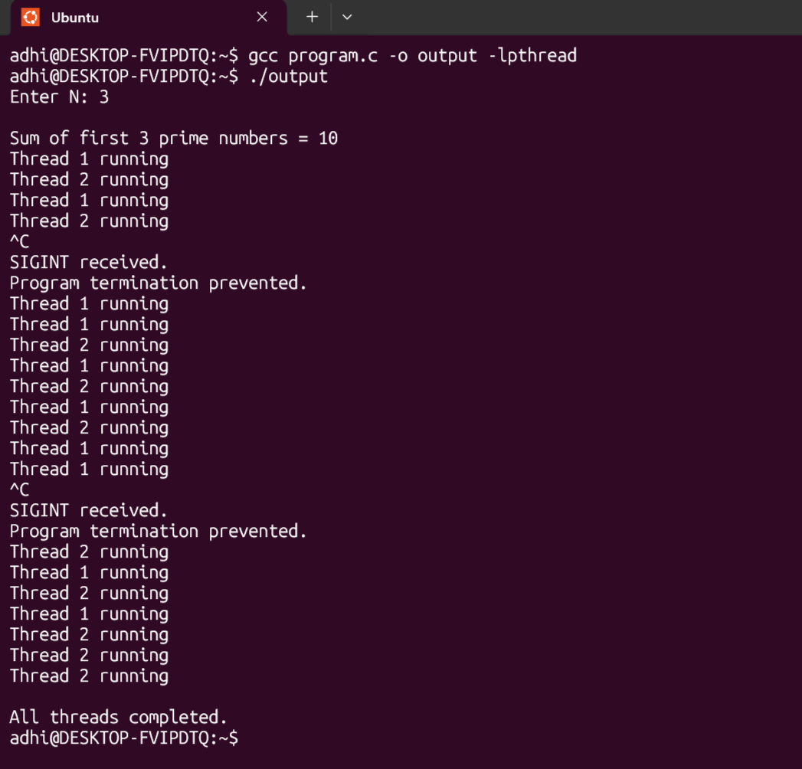

3. Notes
1. Child Process Creation using fork()
To create a child process using the fork() system call and display the process IDs of parent and child processes.

What is a Process?
A process is:
- a program in execution.
Example:
- Browser
- Music player
- VS Code
Each running application is a process.

Parent Process
The original process that creates another process is called Parent Process

Child Process
The newly created process is called Child Process

What is fork()?
fork() is a system call in Linux/Unix used to create a new process.

Working of fork()
When fork() executes:
- OS creates a copy of the parent process.
- Both parent and child continue execution from the next statement after fork().

Return Values of fork()
Return Value | Meaning
0 | Child process
> 0 | Parent process
< 0 | Process creation failed

Important Functions Used
Function | Purpose
fork() | Creates child process
getpid() | Returns current process ID
getppid() | Returns parent process ID
sleep() | Delays execution

Process ID (PID)
Each process gets a unique ID.
Example:
Process | PID
Parent | 2073
Child | 2074

Need for sleep(2)
Sometimes parent process finishes early.
Then child becomes:
Orphan Process
and gets adopted by system process.
So parent PID may change unexpectedly.
Using:
sleep(2);
keeps parent alive temporarily.

Program
#include <stdio.h>
#include <unistd.h>
#include <sys/types.h>
int main()
{
pid_t pid;
/* CREATE CHILD PROCESS */
pid = fork();
/* FORK FAILURE */
if(pid < 0)
{
printf("Fork Failed\n");
}
/* CHILD PROCESS */
else if(pid == 0)
{
printf("\nChild Process Executing\n");
printf("Child Process ID: %d\n",
getpid());
printf("Parent Process ID from Child: %d\n",
getppid());
}
/* PARENT PROCESS */
else
{
printf("\nParent Process Executing\n");
printf("Parent Process ID: %d\n",
getpid());
printf("Child Process ID from Parent: %d\n",
pid);
/* KEEP PARENT ALIVE */
sleep(2);
}
return 0;
}

Compilation Command
gcc prg.c -o output

Run Command
./output

Output

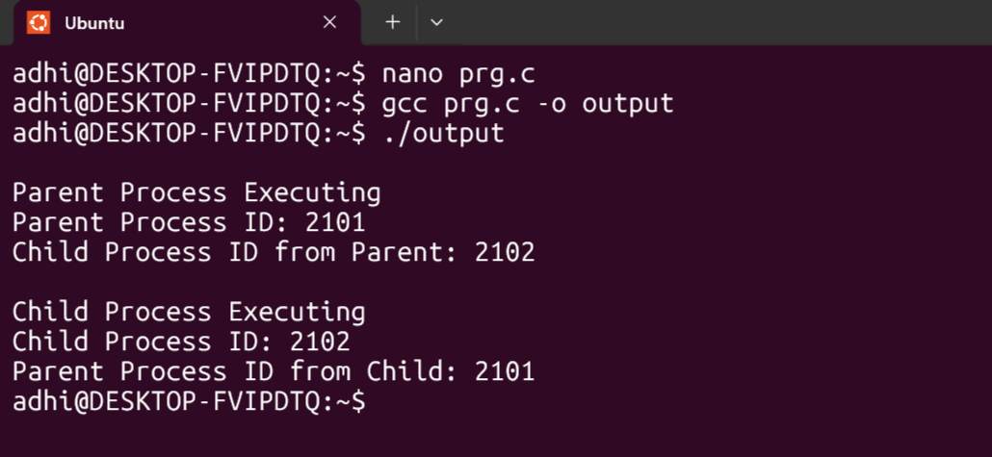

Step-by-Step Execution

Step 1 → Program Starts
Main process begins execution.
parent PID: 2073

Step 2 → fork() Executes
pid = fork();
OS creates child process.
child PID:2074

Step 3 → Parent Process Executes
For parent:
pid > 0
So parent block executes.
Output:
Parent Process Executing
Parent Process ID: 2073
Child Process ID from Parent: 2074

Step 4 → Child Process Executes
For child:
pid == 0
So child block executes.
Output:
Child Process Executing
Child Process ID: 2074
Parent Process ID from Child: 2073

Process Flow Diagram
Parent Process
PID 2073
|
fork()
|
----------------------
| |
Parent Process Child Process
PID 2073 PID 2074

Advantages of fork()
- Supports multiprocessing
- Enables parallel execution
- Used in operating systems
- Used in servers and shells

Applications
- Linux shell
- Web servers
- Background processes
- Process scheduling

Time Complexity

O(1)
because process creation is a system-level operation.

2. Signal Handling

Definition
A signal is a software interrupt sent to a process to notify that an event has occurred.
Example:
- pressing Ctrl + C
- invalid memory access
- program termination request

Why Signals Are Used
Signals are used to:
- interrupt processes
- handle errors
- terminate programs
- communicate with processes

Common Signals
Signal | Meaning
SIGINT | Interrupt signal (Ctrl + C)
SIGTERM | Termination request
SIGKILL | Forcefully kill process
SIGSEGV | Segmentation fault

Signal Handling
Signal handling means:
- capturing a signal
- executing a custom function instead of default action

Example
Normally:
Ctrl + C
terminates the program.
Using signal handling:
- program can prevent termination
- display custom message

Functions Used
Function | Purpose
signal() | Registers signal handler
sleep() | Delays execution

Basic Program
#include <stdio.h>
#include <signal.h>
#include <unistd.h>

void handleSignal(int sig)
{
printf("\nSIGINT received.\n");
}

int main()
{
signal(SIGINT, handleSignal);

while(1)
{
printf("Running...\n");
sleep(2);
}

return 0;
}

Working
When user presses:
Ctrl + C
OS sends:
SIGINT
Then:
- handler function executes
- default termination is avoided

Applications
- OS process management
- Interrupt handling
- Error recovery
- Background services

3. Kernel Crashes

Definition
Kernel crash occurs when the operating system kernel encounters a fatal error and cannot continue execution.
Kernel is:
- the core part of operating system.

Causes of Kernel Crash
- Invalid memory access
- Driver failure
- Hardware issues
- Infinite loops
- Stack overflow

Types of Kernel Crashes
Crash Type | Meaning
Kernel Panic | Critical OS failure
Segmentation Fault | Invalid memory access
Stack Overflow | Excess recursion
Deadlock | Processes wait forever

Kernel Panic
Occurs when:
- kernel cannot recover from error.
System may:
- freeze
- restart
- stop responding

Segmentation Fault
Occurs when:
- program accesses unauthorized memory.
Example:
int *p = NULL;
*p = 10;

Deadlock
Two or more processes wait indefinitely for resources.
Example:
Process A waiting for B
Process B waiting for A

Prevention
- Proper memory handling
- Synchronization mechanisms
- Error checking
- Resource management

Applications
- OS debugging
- Driver development
- Embedded systems

4. Time Complexity

Definition
Time complexity measures:
- how execution time increases with input size.

Why Needed
Helps to:
- compare algorithms
- improve efficiency
- reduce execution time

Common Time Complexities
Complexity | Meaning
O(1) | Constant
O(log n) | Logarithmic
O(n) | Linear
O(n²) | Quadratic

Examples

O(1)
printf("Hello");
Execution time remains same.

O(n)
for(i = 0; i < n; i++)
depends on input size.

O(n²)
for(i = 0; i < n; i++)
{
for(j = 0; j < n; j++)
nested loops.

Importance
- Faster execution
- Better optimization
- Efficient resource usage

Real-Time Example
Searching:
- Linear Search → O(n)
- Binary Search → O(log n)
Binary search is faster.

5. Locking Mechanisms – Mutex and Spinlock

Why Locking is Needed
When multiple threads access shared data simultaneously:
- data inconsistency may occur.
This problem is called Race Condition

Mutex
Mutex means:
Mutual Exclusion
Only one thread can access critical section at a time.

Working of Mutex
- Thread locks resource
- Other threads wait
- After completion, lock is released

Mutex Example
pthread_mutex_lock(&lock);

/* critical section */

pthread_mutex_unlock(&lock);

Spinlock
Spinlock repeatedly checks lock until resource becomes free.
Instead of sleeping:
- thread continuously spins.

Difference Between Mutex and Spinlock
Mutex | Spinlock
Waiting thread sleeps | Waiting thread spins
Better for long wait | Better for short wait
Lower CPU usage | Higher CPU usage

Critical Section
Part of code accessing shared resource.
Example:
- updating bank balance
- modifying shared variable

Applications
- Operating systems
- Multithreading
- Database systems
- Process synchronization

Advantages
- Prevents race conditions
- Ensures synchronization
- Maintains data consistency

